38.29: 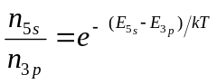
But 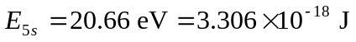
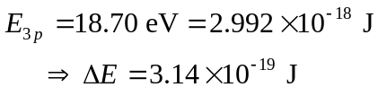
a)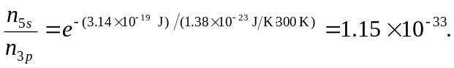
b)
c)
d) The 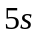state is not highly populated compared to the 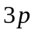state, so very few atoms are able to make the required energy jump to produce the 632.8 nm light.

